BUG REPORT of
master-devops-1727857016.us-east-1.elb.amazonaws.com

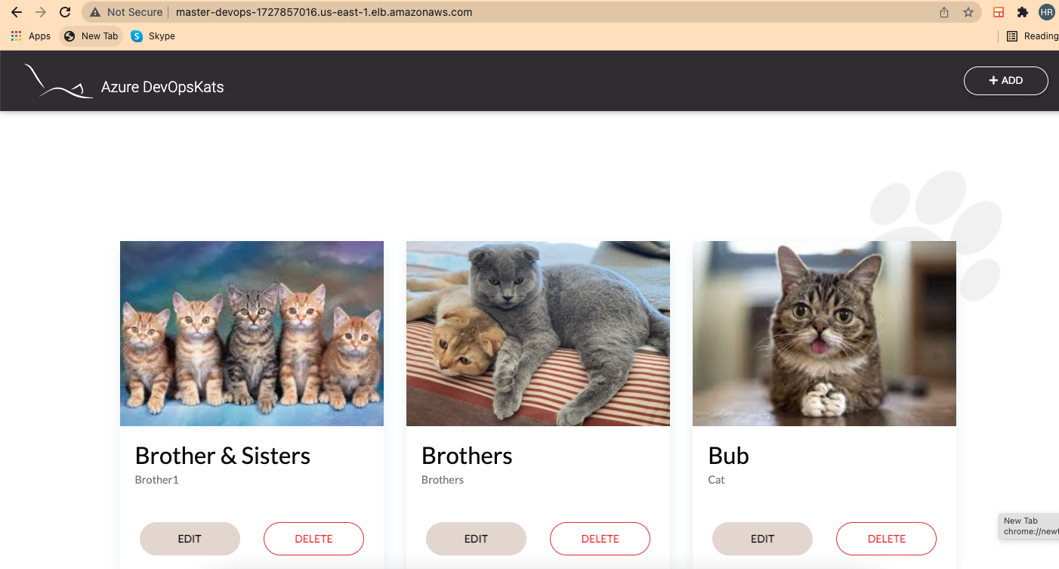

BUGS:
After executing the prepared test cases i have found 8 bugs and those are mentioned below….(WITH TESTCASE ID)
CATS012 : User can enter numbers in the Name field.
CATS013 : User can enter special characters in the Name field.
CATS037 : If the user enters more than 19 letters in Name field it will crash the design.
CATS038 : If the user enters more than 42 letters in Description field it will crash the design.
CATS039 : Newly uploaded cats are not coming in first page.
CATS040 : User cant edit or change the cat image.
CATS041 : User cant upload a picture which is more than 5mb.
CATS042 : User cant get a popup message if the internet connectivity lost.

CONCLUSION :
Please go with the testcases excel sheet and find these 8 issues and resolve.
THANK YOU

